Module 5 assignment solution:
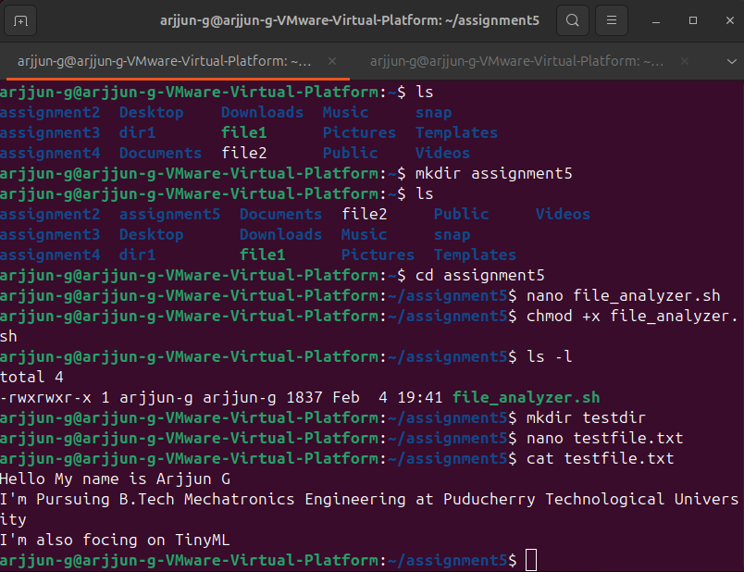
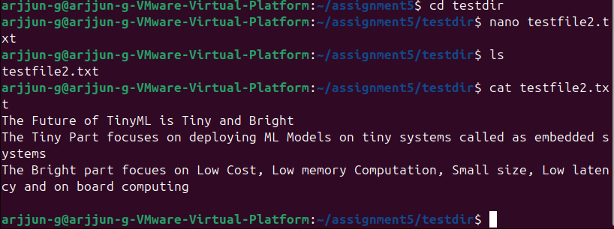
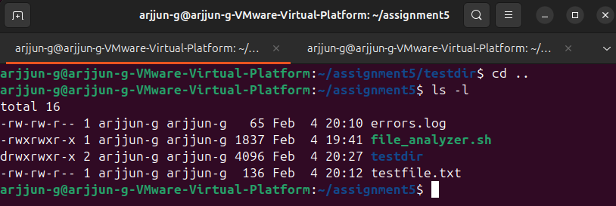
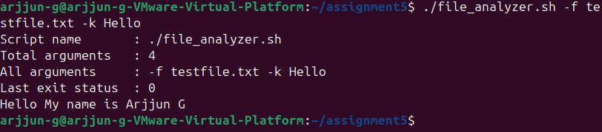
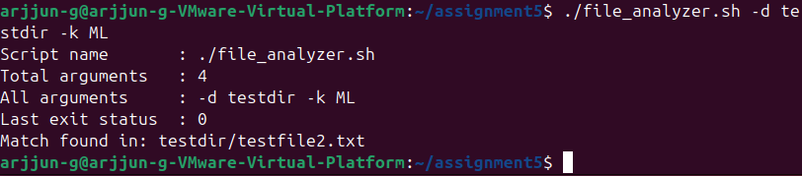
file_analyzer.sh script:
#!/bin/bash

ERROR_LOG="errors.log"

log_error() {
echo "[$(date)] ERROR: $1" | tee -a "$ERROR_LOG"
}

show_help() {
cat << EOF
Usage: $0 [OPTIONS]

Options:
-d <directory> Directory to search recursively
-k <keyword> Keyword to search
-f <file> Search keyword directly in a file
--help Display this help menu

Examples:
$0 -d logs -k error
$0 -f script.sh -k TODO
$0 --help
EOF
}

recursive_search() {
local dir="$1"
local keyword="$2"

for item in "$dir"/*; do
if [ -f "$item" ]; then
grep -q "$keyword" "$item" && echo "Match found in: $item"
elif [ -d "$item" ]; then
recursive_search "$item" "$keyword"
fi
done
}

DIR=""
KEYWORD=""
FILE=""

if [[ "$1" == "--help" ]]; then
show_help
exit 0
fi

while getopts ":d:k:f:" opt; do
case "$opt" in
d) DIR="$OPTARG" ;;
k) KEYWORD="$OPTARG" ;;
f) FILE="$OPTARG" ;;
?) log_error "Invalid option: -$OPTARG"; exit 1 ;;
:) log_error "Option -$OPTARG requires an argument"; exit 1 ;;
esac
done

echo "Script name : $0"
echo "Total arguments : $#"
echo "All arguments : $@"
echo "Last exit status : $?"

if [[ -z "$KEYWORD" ]]; then
log_error "Keyword cannot be empty"
exit 1
fi

if ! [[ "$KEYWORD" =~ ^[a-zA-Z0-9_]+$ ]]; then
log_error "Keyword contains invalid characters"
exit 1
fi

if [ -n "$FILE" ]; then
if [ ! -f "$FILE" ]; then
log_error "File does not exist: $FILE"
exit 1
fi

grep "$KEYWORD" <<< "$(cat "$FILE")"
exit 0
fi

if [ -n "$DIR" ]; then
if [ ! -d "$DIR" ]; then
log_error "Directory does not exist: $DIR"
exit 1
fi

recursive_search "$DIR" "$KEYWORD"
exit 0
fi

log_error "No valid options provided. Use --help"
exit 1

